CSA1717-ARTIFICIAL INTELLIGENCE
PRACTICAL LAB EXPERIMENTS
NIHARIKA PREEJESH (192524506)

PROGRAM 17: MINIMAX ALGORITHM
Aim:
To implement the Minimax Algorithm for optimal decision making in a two-player game.
Objective:
- To determine the best move.
- To maximize the score for MAX.
- To minimize the score for MIN.
Algorithm:
- Start from the root node.
- Evaluate all leaf nodes.
- MAX selects the maximum value.
- MIN selects the minimum value.
- Continue recursively until the root.
- Display the final Minimax value.
Flowchart:
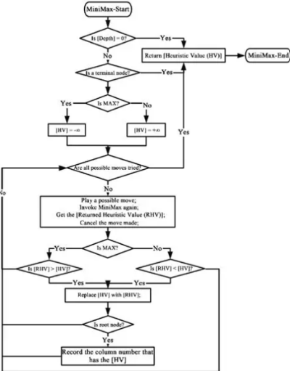

Python Code:
import math

def minimax(depth, node, isMax, values, height):

if depth == height:
return values[node]

if isMax:

return max(
minimax(depth + 1, node * 2, False, values, height),
minimax(depth + 1, node * 2 + 1, False, values, height)
)

else:

return min(
minimax(depth + 1, node * 2, True, values, height),
minimax(depth + 1, node * 2 + 1, True, values, height)
)

values = list(map(int, input("Enter 8 leaf values: ").split()))

height = 3

result = minimax(0, 0, True, values, height)

print("Optimal Value:", result)

Output:
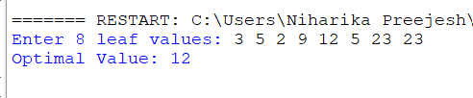

Result: Minimax algorithm was implemented successfully.

